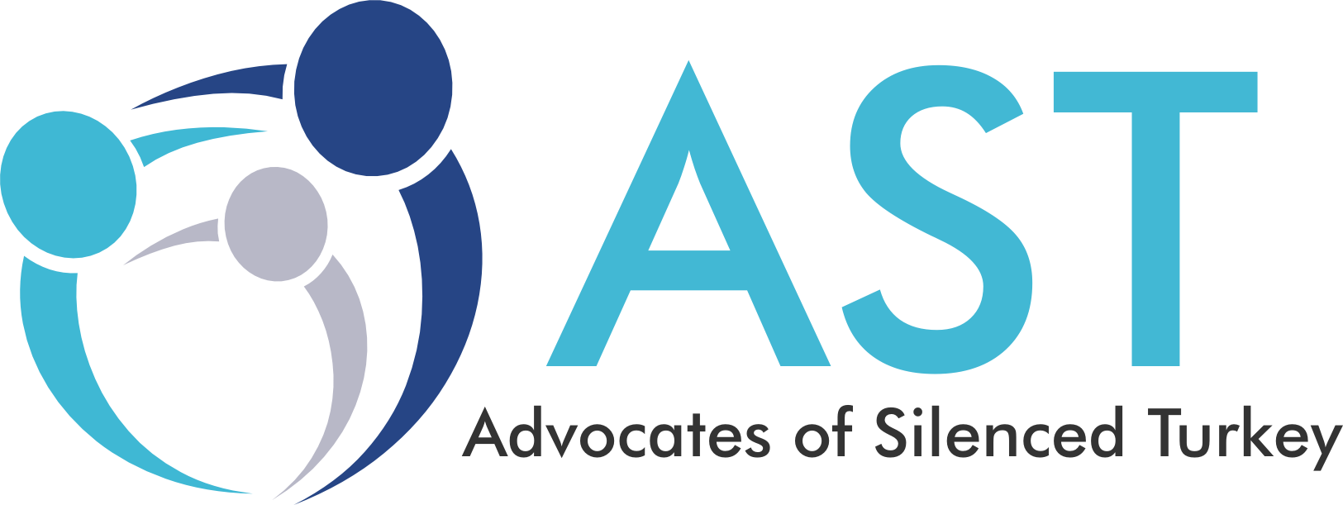

Dear Sir/ Madam

December 24, 2019

Urge **Turkish authorities to investigate and stop the torture of 18 ex-Intelligence employees in Ankara at the counter terrorism department on December 18th and bring perpetrators to justice.**

According to information provided by Bold Medya from ex-MIT employee H.Ç's wife (a lawyer), the detainees were interviewed at 10:30 PM on December 18th, 2019 and threatened with rape using bottles in the counter-terrorism department in Ankara, Turkey.

"My husband was threatened with [my safety], although he did not give details about this part. I think this hurt him deeply. He was threatened with the his family and his mother. Then they showed him bottles lined up side by side and threatened him saying 'Look, we oiled this bottle for you. Today we’re only saying hello, you can guess what we will do tomorrow’” said H.Ç, a lawyer and the wife of one of the detainees.

During the last two years following the so-called coup attempt on July 15, 2016, almost all democratic processes and fundamental human rights have been suspended in Turkey.   
   
The Erdogan administration has greatly restricted access to basic human rights and has abandoned the values of equality and respect for human dignity in the sense that the western civilization stipulates, and in this regard it has completely broken its ties with the modern world. Other reports prepared by many internationally recognized human rights institutions clearly state the same. For example, **the Human Rights Watch published a report about kidnapping and torture in Turkey** (Police Custody Torture and Abductions in Turkey) on **October 2017 while the** **United Nations** published a report on on March 20, 2018 about the widespread human rights violations including torture during Turkey’s state of emergency.  
  
The High Commissioner for UN Human Rights, Zeid Ra’ad Al Hussein, mentioned that about 160,000 people were detained in Turkey; 152,000 state officials, including teachers, judges and lawyers, among whom the vast majority were arbitrarily expelled or investigated; nearly 200 journalists were arrested, 201 media outlets and hundreds of websites were closed during the state of emergency period. **There were many cases of torture, rape and kidnapping, which were only partially reflected in the** reports. As a result of the criminal announcements regarding these issues the limited investigations in Turkey provided no positive result.   
  
**Similarly, the UN rapporteur expressed that 100 pregnant women or women with newborns were taken into custody, severely separated from their children on the grounds that they were "affiliates" with their husbands or older children suspected of being linked to labeled organizations. As best said by the UN rapporteur, "**This is not merely excessive, but entirely cruel!”

FACTS ABOUT TORTURE & DEATHS IN TURKEY

Gokhan Acikkollu, a 42-year old history teacher suffering from diabetes was dismissed from his job then detained & tortured for 13 days under police custody. The result was his death.

The torture allegations documented by the Ankara Bar Association against 6 ex-diplomats of the Turkish Foreign Ministry were detained at Police Headquarters in Ankara on May 26th are another prominent example of torture in Turkey.

According to the UN, there were 263 incidents of torture in the space of a single year and 2,278 victims faced maltreatment and torture. By the count of the State Department there were 328 allegations of torture and at least 51 suspicious deaths in custody and prisons in the last 3 years.

We urge the Turkish authorities to investigate and end state-sanctioned torture in addition to bringing the perpetrators to justice.

We urge all international bodies and human rights organizations to take the necessary steps to STOP TORTURE in TURKEY and bring all the perpetrators to justice.

Source:

<http://aktifhaber.com/m/iskence/mitin-18-eski-calisani-ankara-temde-iskence-goruyor-h140867.html>

#StopTortureInTurkey

Mention List

@adalet_bakanlik

@UNHumanRights

@StateDept

@HelsinkiComm

Advocates of Silenced Turkey

[help@silencedturkey.org](mailto:help@silencedturkey.org)

1-540-209-1934

Silencedturkey.org

Twitter: @silencedturkey

Facebook: @silencedturkey

Dear Hon. Rep. Chris SMITH

Washington, DC Office

2373 Rayburn House Office Building

Washington, D.C. 20515

phone (202) 225-3765

fax (202) 225-7768

COMMISSION ON SECURITY AND COOPERATION IN EUROPE, U.S. HELSINKI COMMISSION

234 FORD HOUSE OFFICE BUILDING

3RD AND D STREETS SW, WASHINGTON, DC 20515

TEL: 202-225-1901 | FAX: 202-226-4199 |

EMAIL: INFO@CSCE.GOV |

Twitter: @HelsinkiComm | Facebook: https://www.facebook.com/helsinkicommission/#

U.N. HUMAN RIGHTS COUNCIL

Twitter: @UN_HRC | https://www.facebook.com/UNHRC

Phone Number: +41 22 917 9656

E-mail: civilsociety@ohchr.org

U.S. DEPARTMENT OF STATE

Address: 2201 C St NW, Washington, DC 20520

Phone Number: (202) 647-4000

Twitter: @StateDept

https://register.state.gov/contactus/contactusform

AMNESTY INTERNATIONAL

Twitter: @amnestyusa | Facebook: https://www.facebook.com/amnestyusa

Report@aiusa.org

@amnesty

@aforgutu

UN HUMAN RIGHTS

U.N. High Commissioner for Human Rights

Office of the United Nations High

Commissioner for Human Rights

Palais des Nations

CH- 121 I Geneva 10. Switzerland

Email: InfoDesk@ohchr.org

REP. CHRIS SMITH -NJ (LANTOS COMMISSION)

Washington, DC Office

2373 Rayburn House Office Building

Washington, D.C. 20515

phone (202) 225-3765

fax (202) 225-7768

https://chrissmith.house.gov/contact/

REP. HASTINGS-FL (HELSINKI COMMITTEE)

Washington, D.C.

2353 Rayburn House Office Building

Washington, DC 20515

Tel: (202) 225-1313

Fax: (202) 225-1171

<https://alceehastings.house.gov/contact/>

Abdülhamit Gül   
Minister of Justice   
Ministry of Justice   
06659 Kizilay   
Ankara, Republic of Turkey   
Email: info@adalet.gov.tr